**VISVESVARAYA TECHNOLOGICAL**

**UNIVERSITY**

Belgaum-590014



**Mini Project Report**

**On**

**“TELEPHONE BILLING PAYMENT SYSTEM ”**

**Submitted in partial fulfillment of the requirements for the subject-wise assignment of SOFTWARE ENGINEERING (18CS35) during 3rd Semester**

# Bachelor of Engineering COMPUTER SCIENCE AND ENGINEERING

**IN**

**For the academic year 2021-2022**

**BY**

Nikil B S 4BD20CS062

Harsha A Sindhe 4BD20CS034

Syed Farhan 4BD20CS104

B R Veeresh 4BD20CS020

Darshan Hiremath 4BD20CS124



# Department of Computer Science and Engineering

# Bapuji Institute of Engineering and Technology

**Shamnur Road, Davanagere-577004**

**Bapuji Institute of Engineering and Technology**

**Davanagere-577004**



# Department of Computer Science and Engineering

**CERTIFICATE**

This is to certify that Nikil B.S, Harsha A Sindhe, Syed Farhan, B.R Veeresh, DarshanHiremathbearingUSNs4BD20CS064,4BD20CS034,44BD20CS104 ,4BD20CS020,4BD20CS124respectively of Computer Science and Engineering department have satisfyingly submitted the mini project report entitled “TELEPHONE BILLING PAYMENT SYSTEM” for SOFTWARE ENGINEERING (18CS35). The report of the mini project has been approved as it satisfies the academic requirements in respect to Mini project work prescribed for the year 2021-22.

Project Guide Head of the department

------------------------ ----------------------------

Ms. Preethi B, MtechDr. Nirmala CR, PhD

Assistant Professor Prof. & Head of the CS&E, Department of CS&E,

BIET, Davanagere BIET, Davanagere.

Date:

Place: Davanagere

# Department VISION and MISSION

**Vision**:

To be a center-of-excellence by imbibing state-of-the-art technology in the field of Computer Science and Engineering, thereby enabling students to excel professionally and be ethical.

**Mission:**

**M1:** Adapting best teaching and learning techniques that cultivates Questioning and Reasoning culture among the students.

**M2:** Creating collaborative learning environment that ignites the critical thinking in students and leading to the innovation

**M3:** Establishing Industry Institute relationship to bridge the skill gap and make them industry ready and relevant

**M4:** Mentoring students to be socially responsible by inculcating ethical and moral values

**Program Specific Outcomes (PSOs)**

**PSO1**: Analyze and develop solutions for problem that are complex in nature but applying the knowledge acquired from the core subjects of this program.

**PSO2:** To develop secure, scalable, resilient and distributed applications for industry and societal requirements

**PSO3:** To learn and apply the concepts and construct of emerging technologies like Artificial Intelligences, Machine learning, Deep learning, Big Data Analytics, IOT, Cloud Computing etc. for any real time problems

**PSO4:** To work in the directional environment by acquiring leadership qualities with effective communication skills accompanied by professional and ethical values

**Program Educational Objective (PEOs)**

**PEO1:** To apply skills acquired in the discipline of Computer Science and Engineering for solving societal and industrial problems with apt technology intervention

**PEO2:** To continue their career in industry/academia or to pursue higher studies and research

**PEO3:** To become successful entrepreneurs, innovators to design and develop software products and services that meets the societal, technical and business challenges

**PEO4:** To work in the diversified environment by acquiring leadership qualities with effective communication skills accompanied by professional and ethical values

**CONTENTS**

**CHAPTERS PAGE NO**

1. **INTRODUCTION 06**
2. **SYSTEM DESIGN 07 – 11**
   1. UML Class diagram **07**
   2. Sequence diagram  **08**
   3. Use case diagram **09**
   4. Activity diagram **10-11**

### SYSTEM REQUIREMENTS AND SPECIFICATION 12

* 1. Functional Requirements
  2. Non Functional Requirements

**INTRODUCTION :**

A phone billing system is a process of gathering consumption data,calculating billing and charging information, availing customer bills, processing thecustomerpayments as well as managing collection of debts.So, with the help of a telephone billing software, the phone billing system is automated helping you to not only improve accuracy but also significantly reduce costs.Consequently, it assists you to manage your billing operations.

**OBJECTIVES:**

The main objectives of the telephone billing payment system is to manage the details of Connexions, customers, Terra fees, connexion types, bills. It manages all the information about Connections, Payments, Bills. The project is totally Built at administrative end and does only the administrator is guaranteed the access. The purpose of the project is to build an application program to reduce the manual for managing the Connections, Customers, Payments, Tarrifs. It tracks all the details about the Tarrifs, Connection types, Bills.

**FEATURES:**

* Provides the searching facilities based on various factors. Such as Connections,Tarrifs, Connections types, bills.
* The transactions are executed in off-line mode, hence on-line data for Connections, customers capture and modification is not possible.
* It tracks all the information of customers, payments, Connection types etc.
* Manage the information of customers.
* Shows the information and description of the Connections, Tarrifs.
* It generates the report on Connections, customers, payments.
* It deals with monitoring the information and transactions of Connection types.

**CHAPTER 2: SYSTEM DESIGN**

**2.1:CLASS DIAGRAM :**

A class diagram in UML describes the structure of asystem by showing the system's classes, their attributes, operations (or methods),and the relationships among objects.These classes inherit from their respectiveappliance type class, and thus from the Appliance class. These classes willcontain the actual implementation of the appliance function.

Telephone billing payment system class diagram describes the structure of a telephone Building PaymentsSystem classes, their attributes, operations and the relationships among the objects.The main classes of the Telephone Billing Payment System are Bills,Customers Connections ,Tarrifs ,Connection Types, Payments

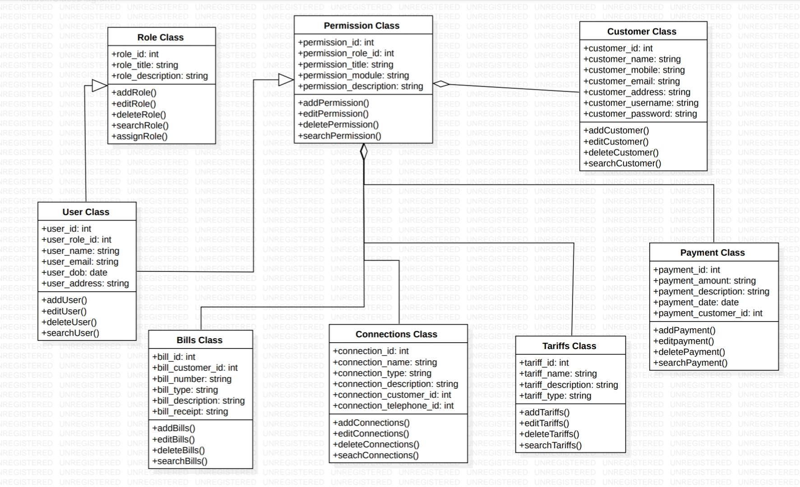

# 2.2:SEQUENCE DIAGRAM:

This is the UML sequence diagram which shows the interaction between the objects of Tarrifs , connections , customers ,bill. The instance of class objects involved in this UML sequence diagram are as follows ;

1.Object

1. Tarrifs Object
2. Connections Object
3. Customers Object
4. Bill Object

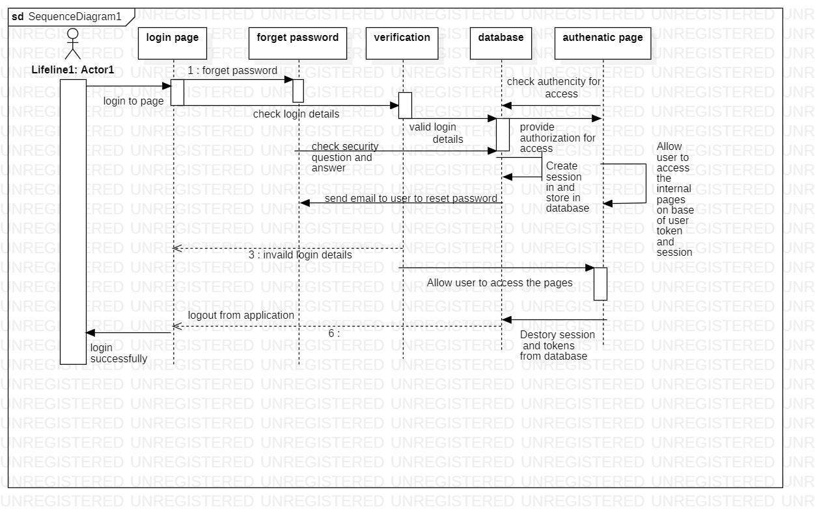

**2.3: USE CASE DIAGRAM:**

The relationship between and among the actors and the use cases of Telephone Billing Payment System :

* **Super Admin Entity**: Use cases of Super Admin are Bills, Manage Customers, Manage Connections, Manage Tarrifs, Manage Connections Types, Manage Payments, Manage Users and Full Telephone Billing Payment System Operations.
* **System User Entity**: Use Cases of System Users are Bills, Manage Customers , Manage Connections, Manage Tarrifs, Manage Connections Types, Manage

Payments.

* **Customer Entity**: Use Cases of Customer are Bills, Make Payment, View Usage, Download Bills, View Payment History.
* **Anonymous Users Entity**: Use Cases of Anonymous Users are View Information Fill Contact Us, Search Content.

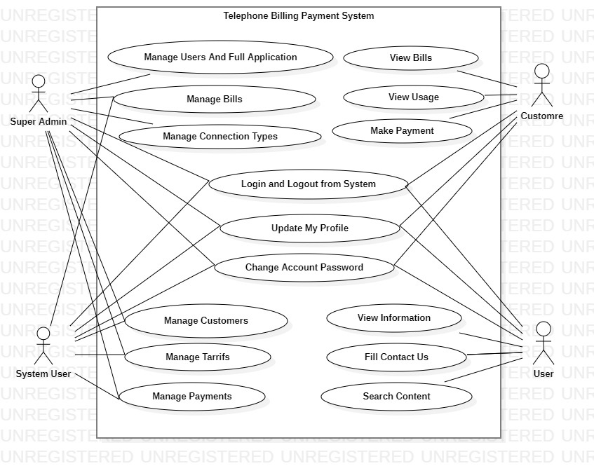

2.4: Telephone Payment Billing System Activity Diagram:

This is the Activity UML diagram of Telephone Billing Payment System which shows

the flows between the activity of Bill, Connection Types, Connections , Customers.

The main activity involved in this UML Activity Diagram of Telephone Billing

Payment System are as follows.

* Bill Activity
* Connection Types Activity
* Connections Activity
* Activity

Features Of The Activity UML Diagram Of Telephone

Billing Payment System

* Admin User can search Bill, view description of a selected Bill, add Bill, update Bill, and delete Bill.
* It shows the activity flow of editing, adding and updating of Connection Types
* User will be able to search and generate report of Connections, Customers.
* All objects such as(Bill, Connection Types)are interlinked
* It shows the full description and flow of Bill, Customers, Connections, Connection Types

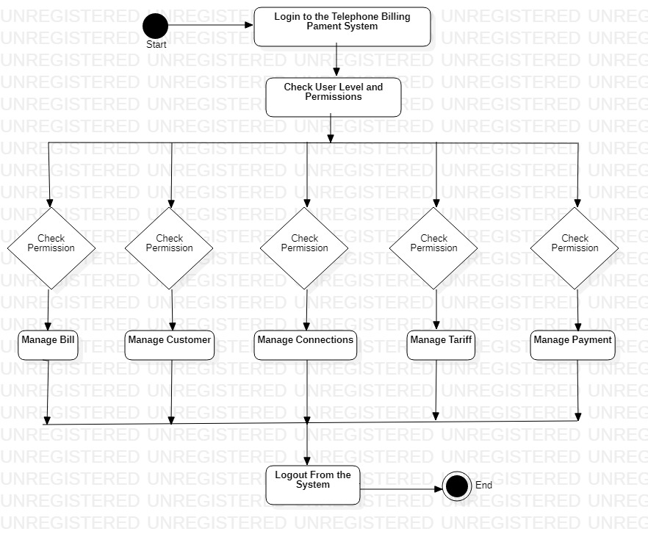

Login Activity Diagram Of Telephone Billing Payment System:

This is the Login Activity Diagram of Telephone Billing Payment System. Which shows the flow of Login Activity, where admin will be able to login using their username and password. After login user can manage all the operations on Connections, Bill, Connection Types. Customers are secure and user can access these page after login.

The diagram below helps demonstrate how the login page works in a Telephone Billing Payment System. The various objects in the Connections, Bill, Connection Types, and Customer page-interact over the course of the Activity, and user will not be able to access this page without verifying their identity.

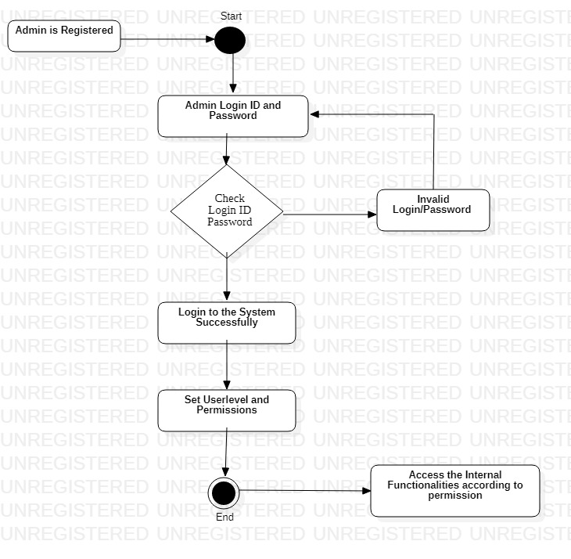

**CHAPTER 3:SYSTEM REQUIREMENTS AND SPECIFICATION**

**FUNCTIONAL AND NON-FUNCTIONAL REQUIREMENTS FOR TELEPHONE BILLING PAYMENT SYSTEM:**

**FUNCTIONAL REQUIREMENTS:**

* Admin must be able to delete the record of the bills.
* Admin must be able to add connection, connection type and login.
* Admin must be able to edit connection, connection type and login.
* Admin must be able to delete connection, connection type and login
* Admin must be able to manage all the detail of customer, and customer payments.
* Admin can also generate the report of bills.
* Admin must be able to generate report of customer, customer connection and connection type.
* Admin must be able to generate the report of customer payment.

**NON – FUNCTIONAL REQUIREMENTS:**

* Maintainability
* Serviceability
* Environmentaly
* Data Integrity
* Usability
* Scalability,Reliability
* Recoverability
* Interoperabilit
* Capacity
* Performance
* Security
* Regulatory